Digital 5.8G Wireless HD AV Transceiver

Product Specifications

Product name: 5.8G wireless digital high-definition Video& Image transmission system
Product model: AJ-DL582
Document version: V18.820.01

Documentation brief description
This document product is developed for the current wireless image transmission market, providing an accessible and integrated wireless transmission system solution for wireless communication products ( such as drones , robots , unmanned ship live broadcasts, remote wireless monitoring, Internet of Things systems, automated scheduling, industrial automation, tower cranes , and video/data access in various other fields ) . It is conducive to product integrated design and product design costs , and can adapt to a variety of wireless module requirements .
This product effectively replaces the defects of short distance , long delay and unclear image of the current WIFI transmission and analog data transmission on the market. Compared with the products on the market, not only the price is lower, but also this product can provide ultra-large bandwidth , support the transmission of 2K and 4K images , and reduce the transmission delay to 10~40ms. It is an image transmission system module with stable performance, super high quality and very advanced technology.
This document mainly provides brief technical parameters and application descriptions of the product.

1. Image transmission products
1. Solution
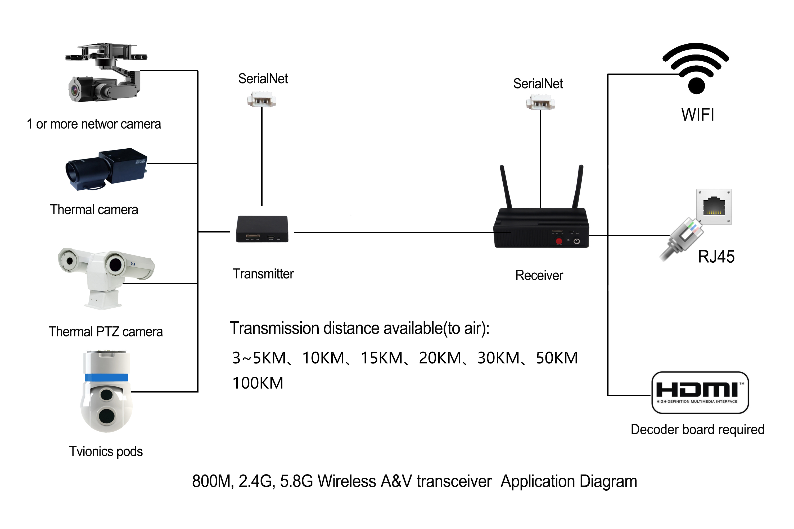

2. Functional characteristics:
● Long-distance transmission: 2 to 5 kilometers in all directions (depending on the environment, weather and other factors)
● Encrypted mode for secure transmission, no fear of data loss
● Two-way channel setting can realize two-way data communication of transmission and reception
● Avoid interference and use 5.8G high frequency band transmission, 32 channels automatic frequency tuning
● High-quality threaded antenna, more stable data transmission
● Support 720P , 1080P, 2K image real-time transmission
● Ultra-low latency, the lowest can reach 10ms , the highest does not exceed 40ms ( the latency is the latency of the image transmission board itself , measured without the camera)
● 5.8G high bandwidth transmission 300Mbps wireless transmission rate Longer transmission distance and faster speed
● Dedicated network interface, seamless connection to network cameras ( digital HD cameras, thermal imagers, infrared cameras, etc.)
● True transparent serial port, which can provide real-time data transmission channel ( transmitting aircraft control commands , position, speed, distance and other data)
● A dedicated HDMI encoding board can be superimposed , seamlessly compatible with all standard HDMI interface cameras on the market
● Network port, wifi mode Connect to mobile phone and computer to output images
● Modular design, can be directly connected to the flight platform
● Dual-channel digital transmission, stable connection, automatic matching, automatic connection after reset

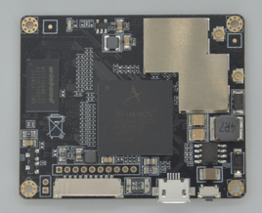
Product images
RF parameters |  | Software Features
RF characteristics | 5G--5.9G adjustable | Working Mode | AP Mode
RF characteristics | South Korea, Japan, ETSL/FCC | set up | Automatic channel selection
RF characteristics | Communication channel optional | set up | Automatic channel selection
Modulation Mode | OFDM=BPSK,QPSK,16-QAM,64-QAM | set up | Automatic channel selection
Modulation Mode | DSSS=SBPSK,DQPSK,CCK | Wireless Security | Security Mechanism 64-bit secure password
Transmission rate | SDR Radio Transmission Stand / 300Mpbs | Wireless Security | Security Mechanism 64-bit secure password
Receiving sensitivity | 802.11n (5.8GHz) | Wireless Security | Security Mechanism 64-bit secure password
Receiving sensitivity | -90dBm@MCSO | Wireless Security | Security Mechanism 64-bit secure password
Receiving sensitivity | -70dBm@MCS7 | Restore settings | Can restore to factory default settings
Receiving sensitivity | -90dBm@MCS8 | Restore settings | Can restore to factory default settings
Receiving sensitivity | -68dBm@MCS15 | Restore settings | Can restore to factory default settings
Receiving sensitivity | 802.11g | Restore settings | Can restore to factory default settings
Receiving sensitivity | -90dBm@6Mbps | Physical properties
Receiving sensitivity | -72dBm@54Mbps | Operating temperature | -20℃~80℃
Receiving sensitivity | 802.11b | humidity | 5%~95% (typical)
Receiving sensitivity | 95dBm@1Mbps | weight | ≈ 2 5g
Receiving sensitivity | -90dBm@11Mbps | Material | Lead-free environmentally friendly material
Motherboard power consumption | Receiver < 2 watts, transmitter < 2.5 watts
Video transmission delay | Air delay: Less than 1.5KM : Less than 10ms 1.5KM or more : Less than 40ms  HDMI interface version delay: iPhone4 and above: Less than 120MS , Android phone: closely related to the phone solution  (Huawei M7: 150ms, some mobile phones reach more than 500ms )
Client | Network port version : Determine the relevant client based on the camera used by the customer  HDMI version: Use open source software that supports RTSP stream address playback
Uart ( serial port) | Adjustable baud rate, seamless connection of flight control data and remote control data, mobile phone OSD display

Technical Parameters
interface | Working status indicator  Two SMA antenna interfaces  A reset button to restore default settings  One DC power port supports 12V local  Video input interface: HDMI, RJ45, other interfaces ( USB , CVBS , SDI , etc.) can be customized  Video output interface : WIFI , USB, other interfaces ( HDMI , different LCD display interfaces, etc.) can be customized | Transmit power | Default minimum: 21dBm/128mw
interface |  | Transmit power | 23dBm@MCS5/MCS13
interface |  | Transmit power | 22dBm@MCS6/MCS14
interface |  | Transmit power | 22dBm@MCS7/MCS15
interface |  | Transmit power | Radio1(WLAN1)
interface |  | Transmit power | 802.11g (±1.5dBm)
interface |  | Transmit power | 25dBm@6~24/Mbps
interface |  | Transmit power | 25dBm@36Mbps
interface |  | Transmit power | 22dBm@48Mbps
antenna | IPEX interface , 5dB omnidirectional antenna, antenna shape can be customized | Transmit power | 22dBm@54Mbps
Product size | 55mm * 45mm * 8.3mm (length*width*height) | Transmit power | 802.11g (±1.5dBm)
Power adapter | 12V-24V/1A;110V/220V | Transmit power | 25dBm@1~11/Mbps

