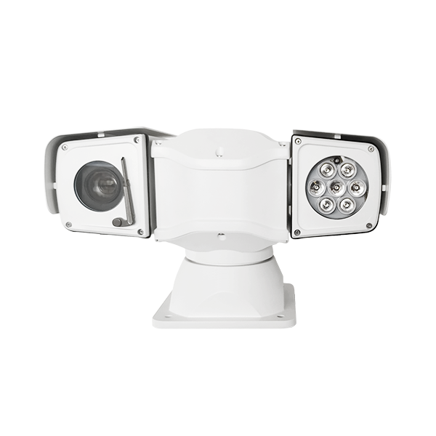
4G T Shape HD PTZ camera

Model：AJ-CT-TW10-4G
Feature：
Single channel 1080P HD video, dual 1080P storage and transmission
Intelligent bit rate adjustment greatly reduces transmission traffic and storage space
H.265, backward compatible with H.264
4G full network communication, remote real-time monitoring, optional dual 4G
Built-in memory card, maximum 256G, combined with intelligent code rate adjustment algorithm, can greatly save storage space
Built-in WIFI, supports hotspot mode working mode
Supports remote export of videos by connecting the station to the router
Support GPS module, precise positioning
The video is superimposed with 4G signal strength information, and the signal quality is read locally and remotely in real time.
Support two-way voice intercom
Support shock-absorbing structure to improve equipment working stability
Infrared distance: 120~150 meters, optional laser light

Applications：
Suitable for Maritime Safety Administration coastal defense monitoring, port monitoring, border control monitoring, forest fire prevention, railway monitoring, airport monitoring
Specifications：
PTZ：
Pan preset speed | 100°/S
Tilt preset speed | 60°/S
Pan manual speed control | 0°～ 60°/S
Tilt manual speed control | 0°～ 40°/S
Pan angle | 360°endless rotation
Tilt angle | -90°～ +90°
Preset position accuracy | ±0.1°
Preset | 256 preset positions, 8 patrol tracks
Wiper | Support
control method | RS485, built-in PELCO D/P protocol, baud rate optional from 2400Bps to 19200Bps
Relative humidity | <90%
Protection level | IP66
Operating temperature | -35°C ～ +55°C
Power consumption | DC10.8～DC18V
Impact resistance requirements | ≥4G
Installation method | Various installation methods are optional according to the application environment
Weight | 7kg

Dimension:(mm)
