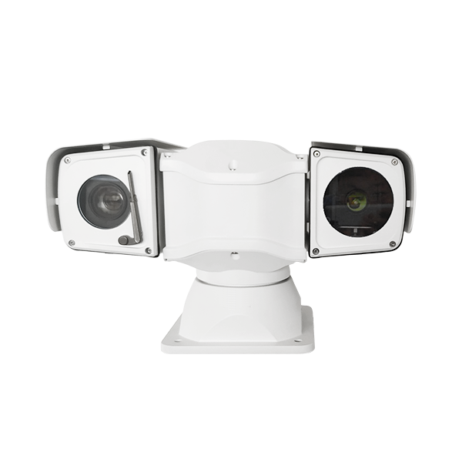
New Vehicle PTZ camera

Model：
AJ-CT-TW10
Feature：
- Independent defogging and defrosting module, which truly solves the fogging of camera lens caused by temperature difference in outdoor environment

● The camera compartment uses high-quality heating parts, so that the front and rear of the entire compartment work together to form an effective anti-fog and defogging pattern.
● PTZ adopts the integrated upper and lower structure so that the PTZ and infrared housing will not bump and dislocate
. The standard voltage stabilizing module filters the instantaneous unstable current of the vehicle and keeps the PTZ in a stable state.
● The high-speed rotation of the PTZ is smoother, and the low-speed rotation is jitter-free.
● High-strength aluminum alloy appearance design, protection grade IP66
● PTZ all-round monitoring without blind spots
IR：Using imported array infrared lights, multiple sets of angles, service life up to 30,000 hours, night vision distance 100~120 meters.
Laser：Imported 808nm laser is used to achieve synchronous zoom, the angle is adjustable or automatically adjusted according to the camera magnification, the laser spot angle is 1° to 50°, and the laser 3/5W is optional.
Thermal：The infrared thermal imaging camera is a product used to detect the infrared radiation of a target object and convert the temperature distribution image of the target object into a video image through photoelectric conversion, electrical signal processing and other means. It adopts the third generation uncooled vanadium oxide ( VOx) infrared focal plane detector, 320×240 pixels.
White light：Using high-intensity lattice white light emitting chip, night vision distance is 50~80 meters。

Application：
Suitable for police car mobile law enforcement/fire emergency command/ first aid command system/road administration mobile patrol/urban security law enforcement/special vehicle mobile inspection.

PTZ：
Pan preset speed | 100°/S
Tilt preset speed | 60°/S
Pan manual speed control | 0°～ 60°/S
Tilt manual speed control | 0°～ 40°/S
Pan angle | 360°endless rotation
Tilt angle | -90°～ +90°
Preset position accuracy | ±0.1°
Preset position | 256 preset positions, 8 patrol tracks
Wiper | Support
control method | RS485, built-in PELCO D/P protocol, baud rate optional from 2400Bps to 19200Bps
Relative humidity | <90%
Protection level | IP66
Operating temperature | -35°C ～ +55°C
Power consumption | DC10.8～DC18V
Impact resistance requirements | ≥4G
Wiper | support
Installation method | Various installation methods are optional according to the application environment
Weight | 7kg
Dimensions of infrared and white light models: (unit: MM)

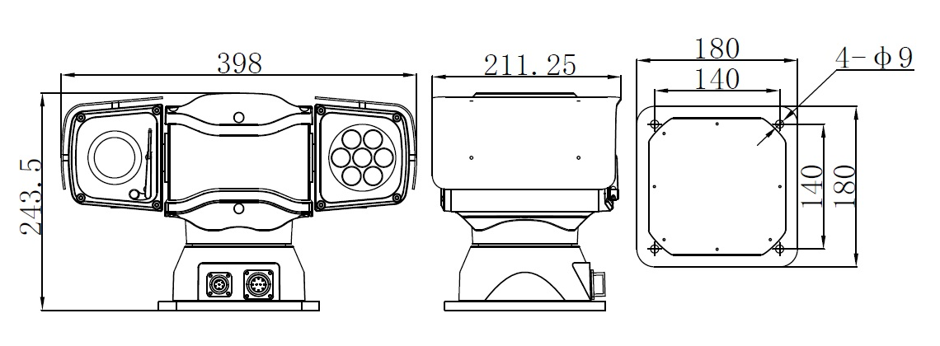

Thermal imaging model and laser light product size chart: (Unit: MM)

