New vehicle PTZ camera

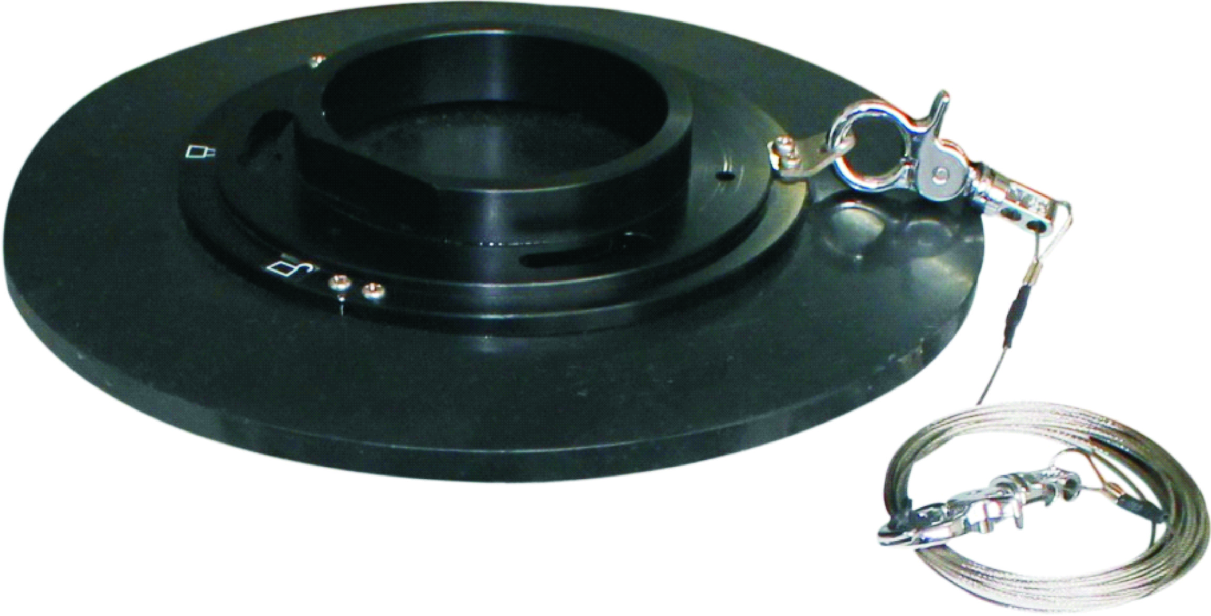
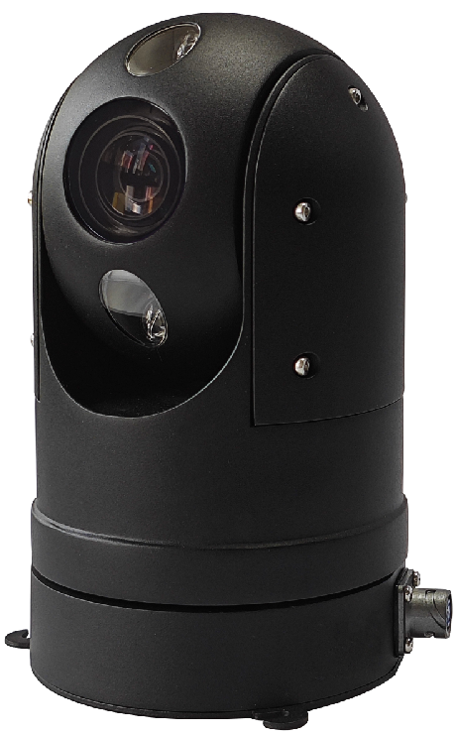
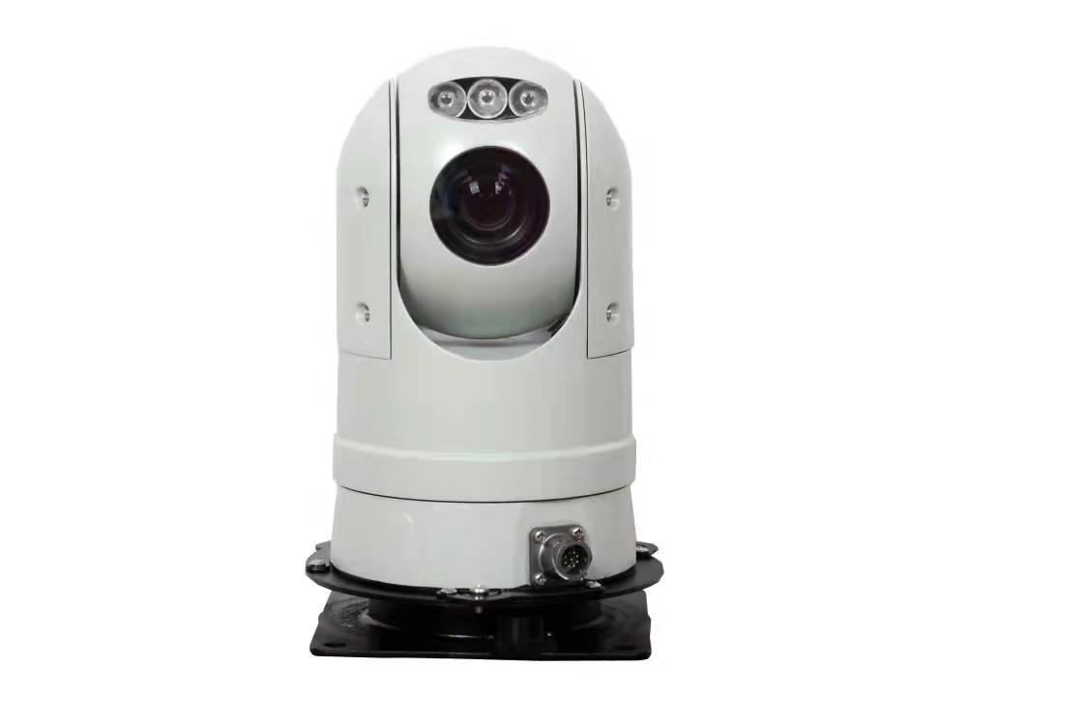
powerful magnetic cup (optional)
Model：AJ-CT-XY001

Feature：
● The PTZ has a variety of installation methods
The bottom shock absorber, combined with the vehicle cloud stand, is installed on the roof of the car.
● Using integrated 8-bit processor, low power consumption and good stability
● Using 0.9° precision motor drive, low speed and smooth operation without jitter
● Use industrial-grade components, suitable for all kinds of severe weather
● Exquisite structural design, aluminum alloy precision casting shell, impact resistance and corrosion resistance
● Can store 256 preset positions, data is stored in power-off memory, and automatically returns to the original state before power-off after power-on.
● Six cruise tracks, four line scan commands, and one pattern scan function can be intelligently set
● With home position function, the position can be returned to track, line scan, and preset position
● The protection level reaches IP66, supporting three levels of lightning protection and surge protection.
IR Night vision：Using imported array infrared lights, the service life can reach 30,000 hours, and the night vision distance is 80 meters.
HD IP： PTZ support mainstream megapixel digital high-definition movement and HD SENSOR HD picture capture, compatible with mainstream HD platform and seamless docking, the maximum support 1080P output, support for dual-stream and high-definition capture, support IE browser

SDI HD：PTZ support megapixel HD movement, HD-SDI digital interface output, megapixel digital high-definition image lossless, real-time transmission, no delay, a variety of resolution adjustable (1080p / 60 1080p / 30 1080p / 25 720p / 60 720p / 30 720p / 25)
Application：Suitable for live broadcast/mobile law enforcement/urban security/video conferencing/urban management security law enforcement/special patrol/smart guard box

Product Specifications：
PTZ：
Pan preset speed | 300°/S
Tilt preset speed | 120°/S
Pan manual speed control | 0°～ 220°/S
Tilt manual speed control | 0°～ 90°/S
Pan angle | 360°°endless rotation
Tilt angle | -20°～ +90°
Preset | 256 positions 6 tracking
control method | RS485, baud rate optional from 2400Bps to 19200Bps
Relative humidity | <90%
Protection level | IP66
Operating temperature | -35°C～+65°C
Power consumption | DC10.8V～DC18V
Impact resistance requirements | ≥4G
Wiper | support
Installation method | Various installation methods are optional according to the application environment
Weight | 2.5kg

Dimension：（unit :MM）

