#### 44023bc4854596d82067b7214415276MODULE： ZN2292

Application Range

Mainly suitable for CCTV,PTZ product development and integration

Product Key Fectures

* 1T intelligent computing powe，Supports deep algorithm learning to improve the performance of intelligent event algorithms
* Resolution up to 2MP（1920×1080）,Output Full HD :1920×1080@30fps Live Image.
* Support H.265/H.264/MJPEG Video Compression Algorithm ,Multi-level Video Quality Configuration and Encoding Complexity Settings
* Starlight Low Illumination，0.0005Lux/F1.4(color),0.0001Lux/F1.4(B/W) ,0 Lux with IR
* 92X Optical Zoom，16X Digital Zoom
* Support basic event functions such as mobile detection
* Support 3-stream Technology, each stream can be independently configured with resolution and frame rate
* ICR automatic switching, 24 hours day and night monitoring
* Support Backlight Compensation, Automatic Electronic Shutter ,adapt to different monitoring environment
* Support 3D Digital Noise Reduction, High light Suppression, Electronic Image Stabilization, 120dB Optical Wide Dynamic
* Supports optical fog transmission, which greatly improves the foggy image effect
* Support 255 Preset,8 patrols.
* Support Timed Capture and Event Capture
* Support One-click watch and One-click cruise functions
* Support 1 audio input and 1 audio output
* Built-in 1 alarm input and 1 alarm output, support alarm linkage function
* Support Micro SD / SDHC / SDXC card storage up to 256G
* ONVIF
* Rich interfaces for convenient function expansion
* Small size and low power consumption, easy to access PTZ

Order Model

Dimensions

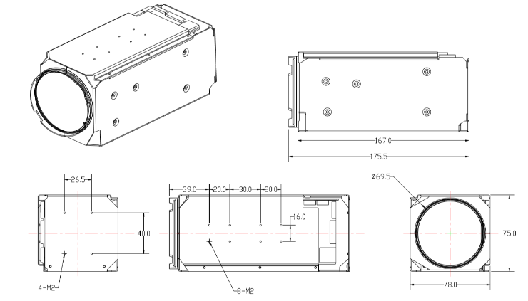

ZN2292

|  |  |
| --- | --- |
| **Specifications** | |
| **Camera** | |
| Image Sensor | 1/1.8” Progressive Scan CMOS |
| Minimum Illumination | color:0.0005 Lux @(F1.4,AGC ON);B/W:0.0001Lux @(F1.4,AGC ON) |
| Shutter | 1/25s to 1/100,000s；Supports delayed shutter |
| Autoiris | PIRIS |
| Day/Night Switch | IR cut filter |
| Digital zoom | 16X |
| **Lens** | |
| Focal Length | 6.1-561mm，92X Optical Zoom |
| Aperture Range | F1.4-F4.7 |
| Horizontal field of view | 65.5-0.78°（wide-tele） |
| Minimum Working distance | 100mm-3000mm (wide-tele) |
| Zoom speed | Approximately 7s(optical lens, wide to tele) |
| **Compression Standard** | |
| Video Compression | H.265 / H.264 / MJPEG |
| H.265 Type | Main Profile |
| H.264 Type | BaseLine Profile / Main Profile / High Profile |
| Video Bitrate | 32 Kbps~16Mbps |
| Audio Compression | G.711a/G.711u/G.722.1/G.726/MP2L2/AAC/PCM |
| Audio Bitrate | 64Kbps(G.711)/16Kbps(G.722.1)/16Kbps(G.726)/32-192Kbps(MP2L2)/16-64Kbps(AAC) |
| **Image（Maximum Resolution：1920×1080）** | |
| Main Stream | 50Hz: 25fps (1920 × 1080, 1280 × 960, 1280 × 720); 60Hz: 30fps (1920 × 1080, 1280 × 960, 1280 × 720) |
| Third Stream | 50Hz: 25fps(704 ×576); 60Hz: 30fps(704 ×576) |
| Image settings | saturation, brightness, contrast, sharpness adjusted by IE/ Client |
| BLC | Support |
| Exposure mode | AE / Aperture Priority / Shutter Priority / Manual Exposure |
| Focus mode | Auto Focus / One Focus / Manual Focus / Semi-Auto Focus |
| Area exposure / focus | Support |
| Optical fog | Support |
| Image stabilization | Support |
| Day/Night Switch | Automatic, manual, timing, alarm trigger |
| 3D noise reduction | Support |
| Picture overlay switch | Support BMP 24-bit image overlay, customizable area |
| Region of interest | ROI supports three streams and four fixed areas |
| **Network** | |
| Storage function | Support Micro SD / SDHC / SDXC card (128G) disconnected local storage, NAS (NFS, SMB / CIFS support) |
| Protocols | TCP/IP,ICMP,HTTP,HTTPS,FTP,DHCP,DNS,RTP,RTSP,RTCP,NTP,SMTP,SNMP,IPv6 |
| Interface Protocol | ONVIF(PROFILE S,PROFILE G) |
| **Smart Features** | |
| Intelligent computing power | 1T |
| **Interface** | |
| External Interface | 36pin FFC (Network port、RS485、RS232、SDHC、Alarm In/Out、Line In/Out、power) |
| **General** | |
| Working Temperature | -30℃~60℃, humidity≤95%(non-condensing) |
| Power supply | DC12V±25% |
| Power consumption | 2.5W MAX(IR Maximum,4.5W MAX) |
| Dimensions | 175.5x75x78mm |
| Weight | 950g |

We will try our best to provide standard and comprehensive information, but will not be responsible for errors or omissions in the information. The product pictures are for reference only, and the actual products shall prevail.