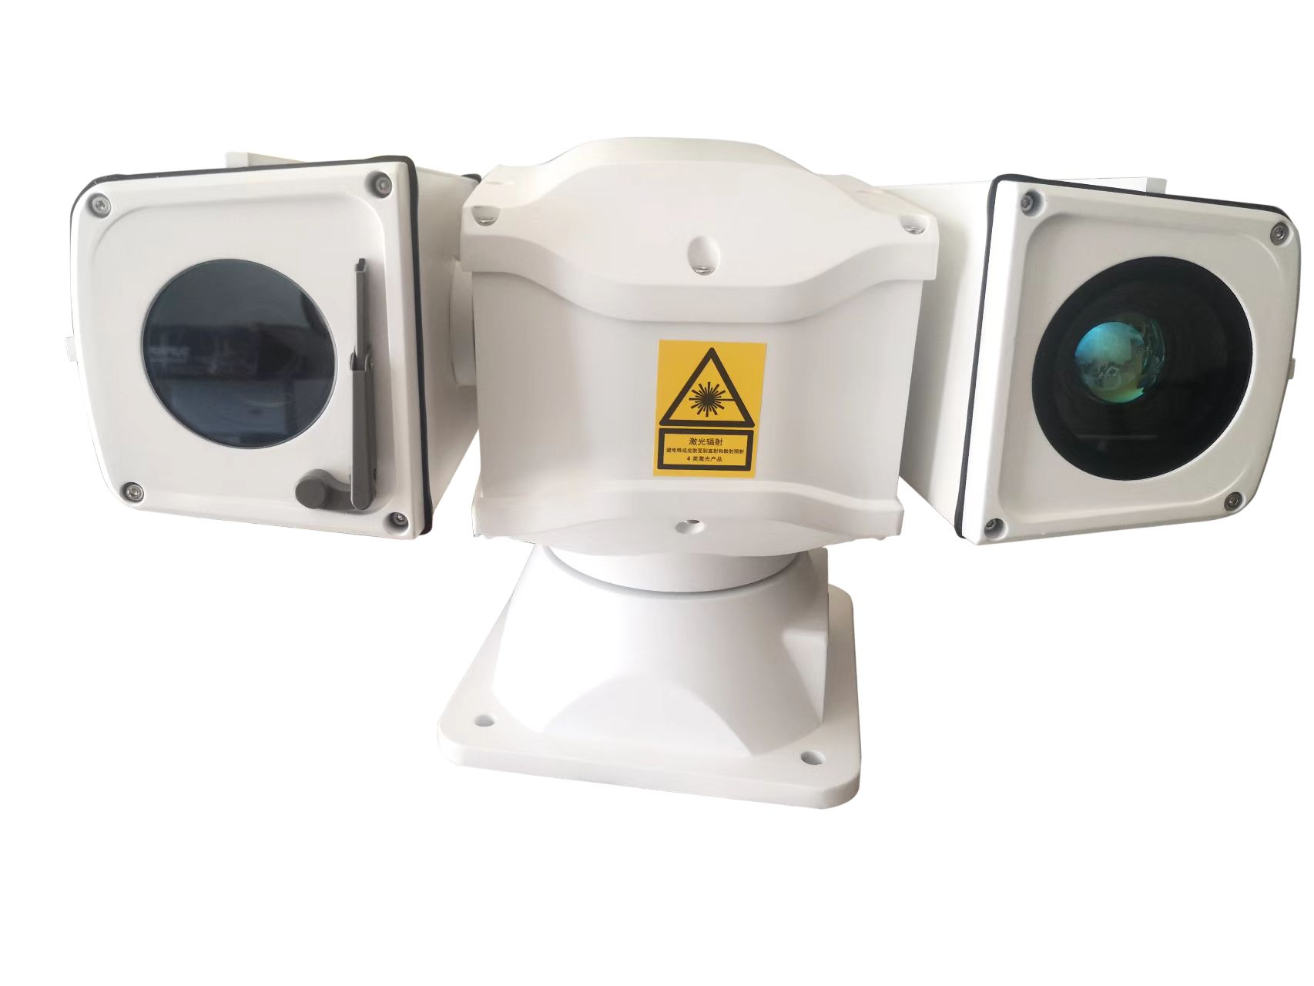
Vehicle Mounted Thermal Camera IP Mobile Infrared 640x512 25mm /Day camera 32X Thermal Lens Thermal PTZ Camera
Model number:AJ-CT-SH05/640/32X

Product Description:
Uncooled Thermal Imaging Camera
1. 640 ×512 high-resolution cooling detector, 12μm pixel, NETD≤50mK, clearer observation of small targets, long detection distance;
2. 25mm, , FOV14.8° × 11.2°.
3. DDE function, output hot white / hot black / pseudo color image.
4. Low power consumption, fast start-up, stable performance, clear and uniform image;

HD Daylight Camera
1. 1/2.8", 2.0 megapixel, progressive scan, CMOS
2. 5.9～188.8mm, 32x Optical Zoom
3. 2Mp(1920x1080) Resolution
4. Up to 120dB WDR (Wide Dynamic Range)
5. Optional network interfaces with Ethernet RJ45.
6. ONVIF Conformance
7. 6KV surge protection designed for network interface.
8. Electric image stabilization
9. Defog function (optional)

Features
1. With continuous zoom thermal imaging technology, the image is clear, enabling wide-range search and recognition of distant targets;
2. High resolution UPFA detector with high temperature sensitivity, NETD≤50mK;
3. Day &night 4MP low-illuminance color camera with IVS functions;
4. Multi-position intelligent recognition auto focus technology, can adapt to a variety of scene changes, to achieve fast focus;
5. Optional preset function, can remember FOV of each preset, improve work efficiency;
6. Fit housing, Aluminum alloy material, with Nitrogen inside, can work under harsh environment, anti-salt fog, anti-corrosion, anti-acid rain, suitable for marine environment(customization);
7. A variety of communication interfaces can be connected and the protocol can be customized, integrated with LRF, DMC, GPS, Radar and tracking module to achieve linkage and tracking functions;
8. External distribution box, with power adapter, video server, Ethernet switch, lightning protector etc. inside, can remote control of Power ON/OFF

Specification parameter
Day camera
Image Sensor | 1/2.8” progressive scan CMOS
Min. Illumination | Color:0.05 Lux @(F1.6,AGC ON); Black:0.005Lux @(F1.6,AGC ON);
Image sizes | 1920×1080
Compressed format | H.264/H.265
Focal Length | 5.9-188.8mm，32x optical zoom
Protocol | IPv4/IPv6,HTTP,HTTPS,802.1x,Qos,FTP,SMTP,UPnP ,DNS,DDNS,NTP,RTSP,RTCP,RTP,TCP/IP,DHCP ,Bonjour
Interface Protocol | ONVIF(PROFILE S,PROFILE G)
Thermal Imaging camera
Resolution | 640X512
Pixel spacing | 17μm
Response band | 8-14μm
Sensitivity(NETD) | ≤50mk@300K
Lens | 25 mm
FOV | 14.8° × 11.2°.
Lens F Value | F1.0
Grayscale alarm | Realize image tag alarm, serial communication alarm, IO alarm
polarity | Black hot/white hot  Pseudocolor
Control interface | RS-232/RS-485/UART/RS-422
Mechanism Parameter
Pan Range | 360° (endless)
Pan Speed | 0.5°/s ~ 60°/s
Tilt Range | –90° ~ +90° (auto reverse)
Tilt Speed | 0.5° ~ 60°/s
Preset/track | 256 preset,6 cruising tracks
Communication | Pelco D & Pelco P; 2400bps to 19200bps for optional,RS485 control
Auto pan speed | 0.5~60°/s
Pattern tour | Four pattern tours ,each one can record 200s
4 Alarm in | Normal open, when closed alarm
1 Alarm out | NC/NO output
Heat/defrost/wiper | Standard configuration
Power supply | DC9-36V±10%
Power consumption | ≤40W
Weight | Max.7.5Kg
Installation method | Flat base installation, support hoisting, wall mounting
Relative humidity | 10-90%RH
Operating temperature | -40°C~+60°C
Dustproof & waterproof | IP66

dimension：
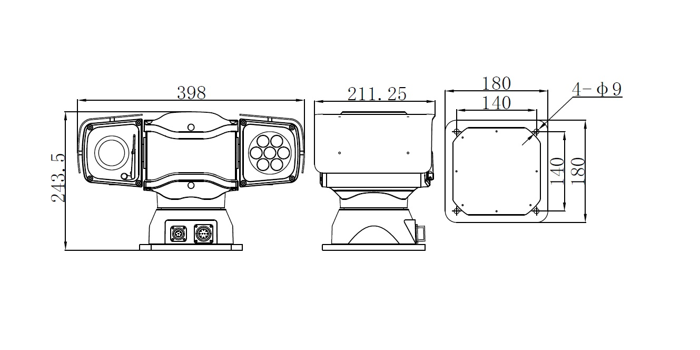

ABOUT CUSTOMIZATION
The long range PTZ thermal imaging camera is one our featured cameras with OEM/Customization supported, which could be designed and produced according to different project requirements & budget with all modules and mechanical structual optional.

Below are regular items which could be customized: NO MOQ Required.

1. Thermal lens: athermalzied lens optional
2. Thermal sensor/detector: uncooled/cooled, with 384/640/1280 resolution for choice
3. Day camera lens: Optical fog penetration, 2x extender optional
4. Day camera: Analog/HD with 2mp, 4mp etc
5. Other modules: Laser Rangefinder with up to 30km; GPS; E-compass; Target auto-tracking; Inclinometer etc.

Please contact us for further/detail needs.
Various configurations are optional and customizable
1. Cameras can be configured according to the specific requirements of the project;
2. Different modules can be selected according to the project budget;
3. OEM and ODM are available;
4. New products can also be jointly developed
Modular design, easy maintenance
1. Device firmware can be upgraded remotely, and engineers can remotely solve device program failures
2. Hardware modular assembly, people with basic electrical knowledge can realize the replacement of faulty modules. Greatly saves the time and cost of maintenance.
3.In normal use, cleaning and maintenance are simple, and there is almost no additional cost
Multiple Shipping Methods
Express, air, sea, land and other methods are optional. You can choose the best way you prefer.
Third Party Guarantee

