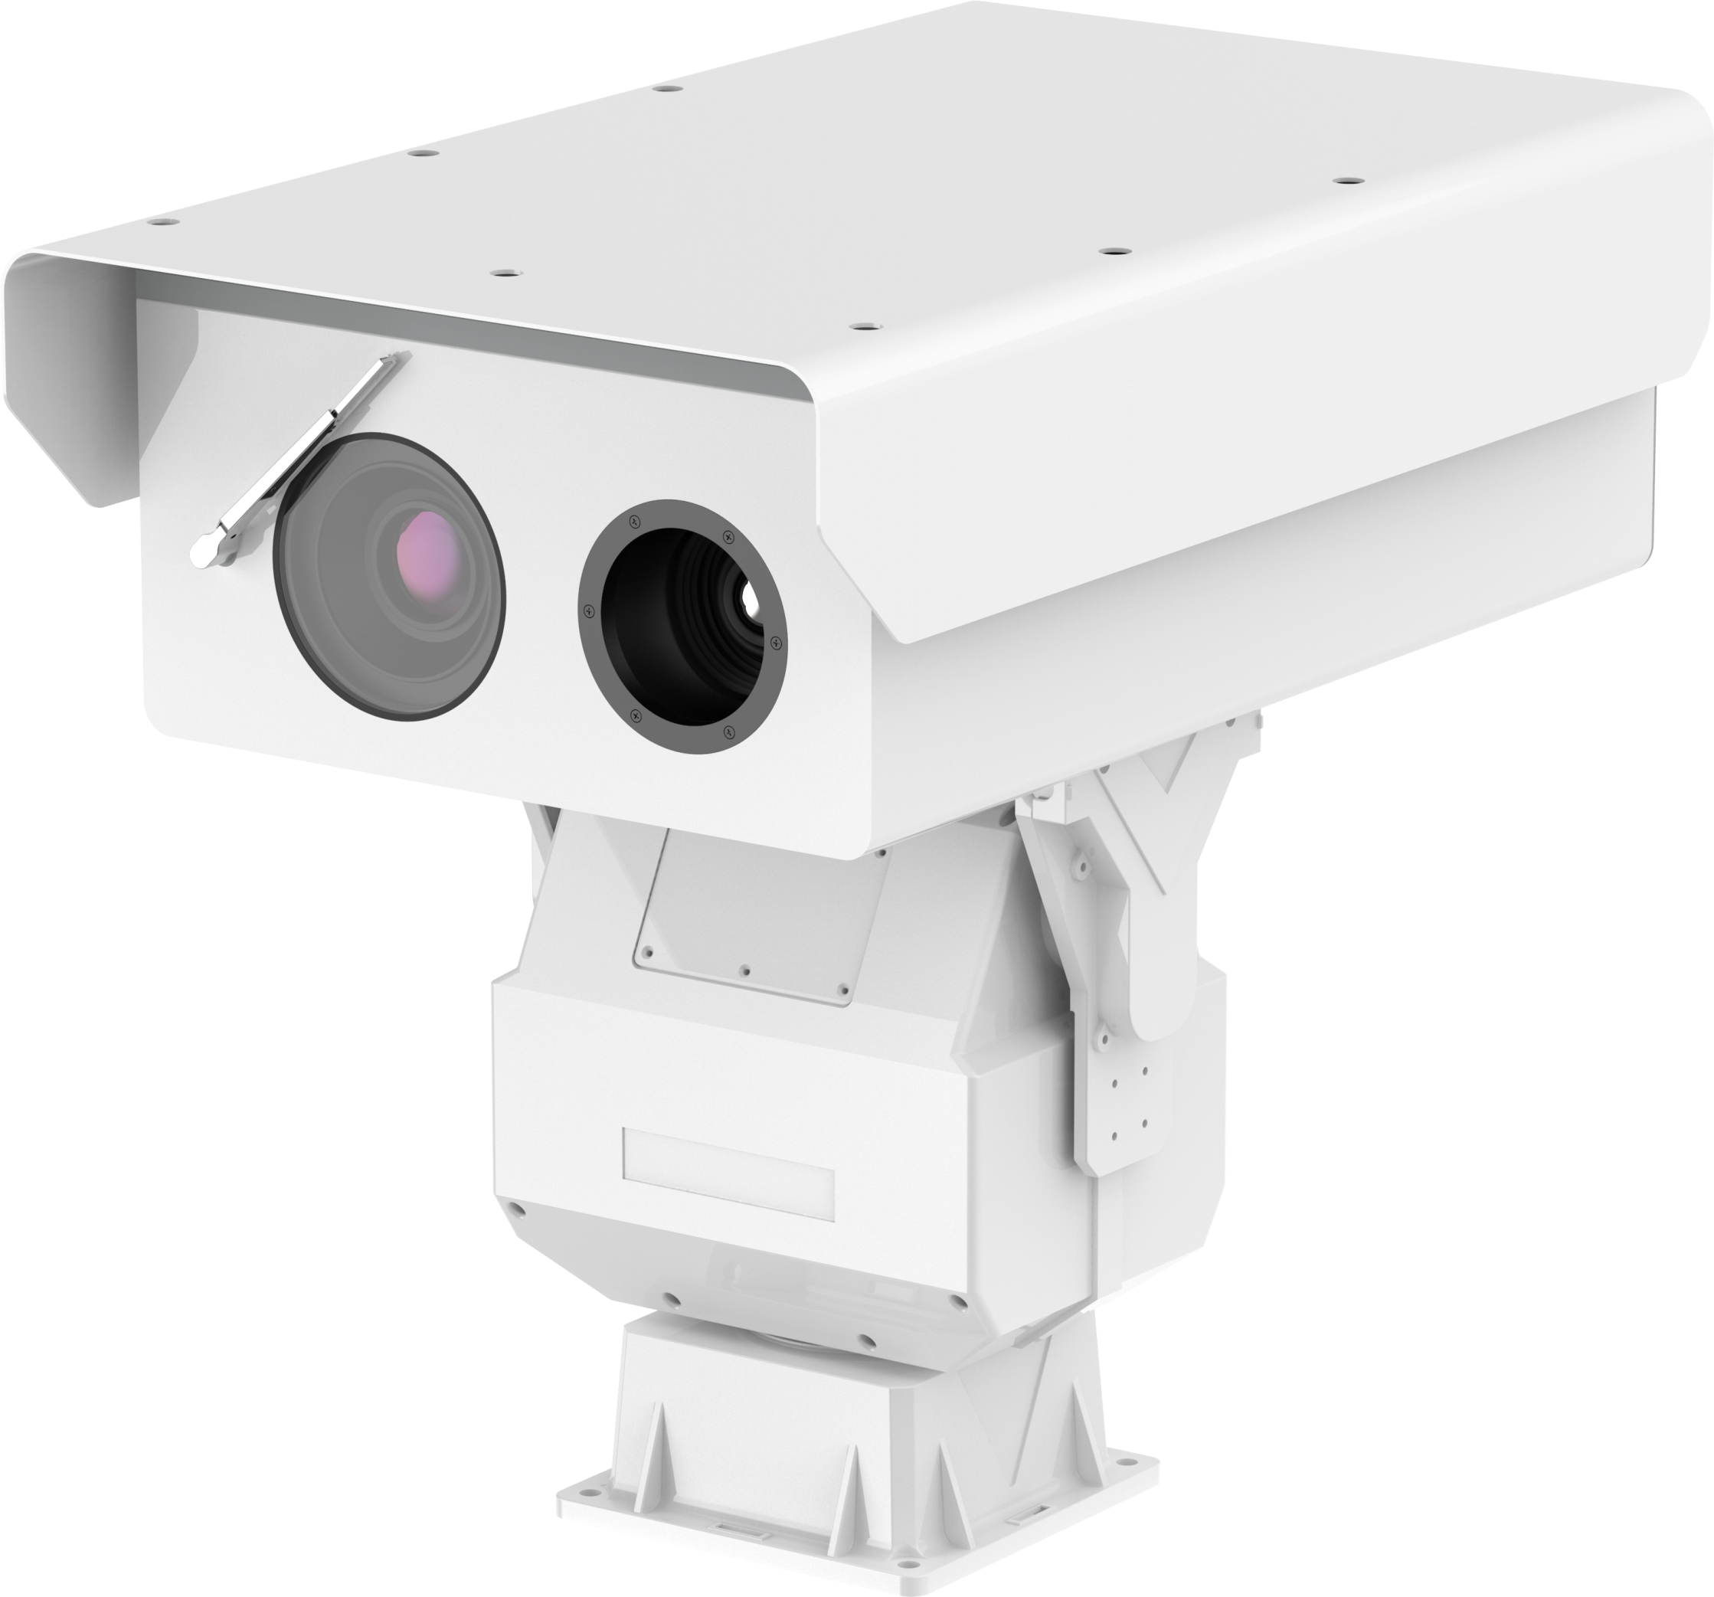
Vehicle Mounted Thermal Camera IP Mobile Infrared 640x512 25-225mm /Day camera 52X Thermal Lens Thermal PTZ Camera
Model number:AJ-TPTZ/640/50X

Product Description:
Uncooled Thermal Imaging Camera
1. 640*512 high-resolution cooling detector, 12μm pixel, NETD≤50mK, clearer observation of small targets, long detection distance;
2. 25-225mm, , FOV2.0°×1.6°~17.7°×14.1°.
3. DDE function, output hot white / hot black / pseudo color image.
4. Low power consumption, fast start-up, stable performance, clear and uniform image;
5. Detection range (person:1.8*0.5m):8000m
Detection range (car: 4.0*1.4m):22000M
Detection distance (fire:3m*3m):18000M

HD Daylight Camera
1. 1/2.8", 4.0 megapixel, progressive scan, CMOS
2. 6.1～317mm, 52x Optical Zoom FOV65.5 ~ 1.8°.
3. 4Mp(2560*1440) Resolution
4. Up to 55dB WDR (Wide Dynamic Range)
5. Optional network interfaces with Ethernet RJ45.
6. ONVIF Conformance
7. 6KV surge protection designed for network interface.
8. Electric image stabilization
9. Defog function (optional)

Features
1. With continuous zoom thermal imaging technology, the image is clear, enabling wide-range search and recognition of distant targets;
2. High resolution UPFA detector with high temperature sensitivity, NETD≤50mK;
3. Day &night 4MP low-illuminance color camera with IVS functions;
4. Multi-position intelligent recognition auto focus technology, can adapt to a variety of scene changes, to achieve fast focus;
5. Optional preset function, can remember FOV of each preset, improve work efficiency;
6. Fit housing, Aluminum alloy material, with Nitrogen inside, can work under harsh environment, anti-salt fog, anti-corrosion, anti-acid rain, suitable for marine environment(customization);
7. A variety of communication interfaces can be connected and the protocol can be customized, integrated with LRF, DMC, GPS, Radar and tracking module to achieve linkage and tracking functions;
8. External distribution box, with power adapter, video server, Ethernet switch, lightning protector etc. inside, can remote control of Power ON/OFF

Specification parameter
Day camera
Image Sensor | 1/1.8” progressive scan CMOS
Min. Illumination | Color:0.05 Lux @(F1.6,AGC ON); Black:0.005Lux @(F1.6,AGC ON);
Image sizes | 2560*1440
Compressed format | H.264/H.265
Focal Length | 6.1-317mm，52x optical zoom
FOV | 65.5 ~ 1.8°
Protocol | IPv4/IPv6,HTTP,HTTPS,802.1x,Qos,FTP,SMTP,UPnP ,DNS,DDNS,NTP,RTSP,RTCP,RTP,TCP/IP,DHCP ,Bonjour
Interface Protocol | ONVIF(PROFILE S,PROFILE G)
Thermal Imaging camera
Resolution | 640*512
Pixel spacing | 12μm
Response band | 8-14μm
Sensitivity(NETD) | ≤50mk@300K
Lens | 25-225mm
FOV | 2.0°×1.6°~17.7°×14.1°
Lens F Value | F1.2
Detection range | Detection range (person:1.8*0.5m):8000m  Detection range (car: 4.0*1.4m):22000M  Detection distance (fire:3m*3m):18000M
Grayscale alarm | Realize image tag alarm, serial communication alarm, IO alarm
polarity | Black hot/white hot  Pseudocolor
Control interface | RS-232/RS-485/UART/RS-422
Mechanism Parameter
Pan Range | 360° (endless)
Pan Speed | 0°/s ~ 45°/s
Tilt Range | –45° ~ +40° (auto reverse)
Tilt Speed | 0° ~ 30°/s
Preset/track | 256 preset,6 cruising tracks
Communication | Pelco D & Pelco P; 2400bps to 19200bps for optional,RS485 control
Auto pan speed | 0~30°/s
Pattern tour | Four pattern tours ,each one can record 200s
4 Alarm in | Normal open, when closed alarm
1 Alarm out | NC/NO output
Heat/defrost/wiper | Standard configuration
Power supply | DC36V±10%
Power consumption | ≤120W
Weight | Max.48Kg
Installation method | Flat base installation
Relative humidity | 10-90%RH
Operating temperature | -40°C~+60°C
Dustproof & waterproof | IP66

dimension：
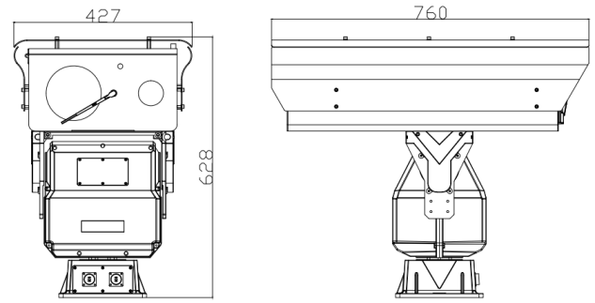Reference (customized according to lens size)

